

CSC222 Database Systems
CSC222L Database Systems Lab
Project Name: University Lab Management
Prepared by: Mohammad Omar Salameh
2020240078

Fall 2025
Academic Year 2025-2026

Contents
Abstract 3
1. Introduction 4
2. System Overview 4
3. Business Rules 4
A) Interpretation 4
B) Relationships and Cardinality 5
4. Entity–Relationship (ER) Design 6
5. Relational Model 6
6. Relational Schema 7
7. SQL Implementation 7
8. Conclusion 8

Abstract
This report presents the design and implementation of a University Lab Booking and Equipment Management System intended to support efficient management of laboratory facilities in a university environment. The proposed database system organizes information related to campuses, laboratories, users, courses, equipment, bookings, and maintenance activities. It enables users with different roles to reserve laboratories, allocate required equipment, and report maintenance issues while ensuring data consistency and integrity. The design is based on clearly defined business rules and is modeled using an entity–relationship approach that is subsequently transformed into a relational schema. Appropriate constraints are applied to maintain referential integrity and enforce valid booking and equipment statuses. The resulting database provides a structured, scalable, and reliable solution for managing academic laboratory resources and can be extended to support additional operational and administrative requirements in the future.

1. Introduction
This report presents the design of a University Lab Booking and Equipment Management System. The purpose of this database is to support universities, in managing laboratory facilities, equipment resources, user reservations, and maintenance activities in an organized and efficient manner. The system aims to ensure proper utilization of laboratories, avoid scheduling conflicts, track equipment usage, and maintain accurate records of maintenance issues.

2. System Overview
The proposed system manages multiple campuses, each containing several laboratories equipped with various types of equipment. Users with different roles (students, instructors, and administrators) can book laboratories, request equipment, and report maintenance issues. The database is designed to support academic courses, lab sessions, and operational activities while maintaining data integrity and consistency.

3. Business Rules
In a University Lab Booking and Equipment Management System, there is one campus that contains laboratories distributed across three floors. For the campus, the campus ID and name are stored. Each laboratory belongs to this campus and is located on one of the three floors; for each laboratory, the laboratory ID, name, floor number, type, and capacity are stored. Users of the system include students, instructors, and administrators, and for each user, the user ID, name, email, and role are stored. Courses are stored with their course ID, course code, course name, and date and time. Laboratories can be booked by users, where the booking start date and end date are stored. A laboratory can have multiple bookings, and a user can create multiple bookings; however, each booking belongs to one user and one laboratory. A booking may be associated with one course or may not be associated with any course. Equipment items are stored with their equipment ID, name, category, status, and the laboratory to which they belong. A laboratory may contain multiple equipment items, while each equipment item belongs to exactly one laboratory.

Interpretation
In our DBMS we have the following entities:
- Campus
  - campus_id
  - name

- Laboratory
  - lab_id
  - name
  - floor_number
  - lab_type
  - capacity
  - campus_id

- User
  - user_id
  - full_name
  - email
  - role: Student, Instructor, Administrator

- Course
  - course_id
  - course_code
  - course_name
  - course_date
  - course_time

- Booking
  - booking_id
  - start_datetime
  - end_datetime

- Equipment
  - equipment_id
  - name
  - category
  - status
  - lab_id

Relationships and Cardinality

- Campus Laboratory
- The Campus has many labs one to many

- Laboratory Booking
- Each Lab can have many Bookings one to many

- User Booking
- Each User can create many Bookings one to many

- Course Booking
- One Course can be associated with one Booking one to one

- Laboratory Equipment
- Each Lab contains many Equipment items one to many

4. Entity–Relationship (ER) Design
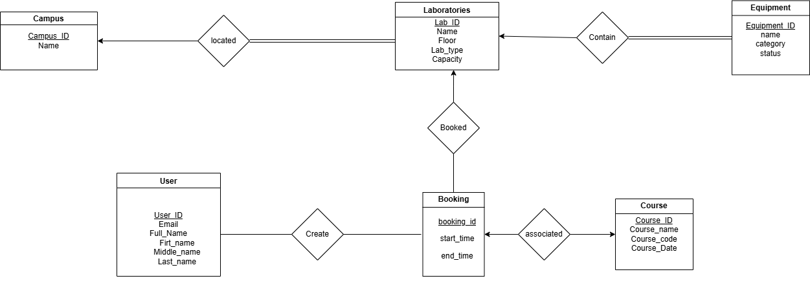

5. Relational Model
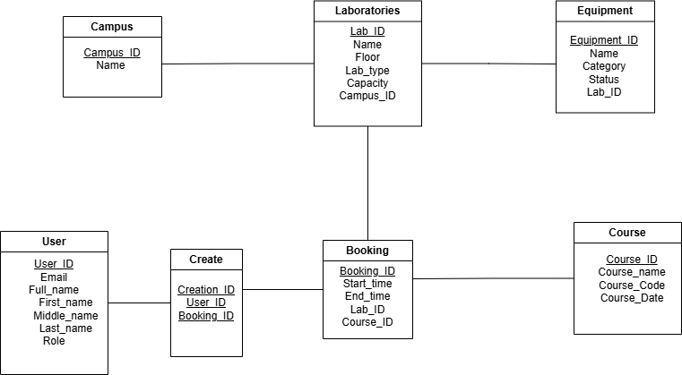

6. Relational Schema
campus ( campus_id PK, name )
laboratory ( lab_id PK, name, floor_number, lab_type, capacity, campus_id FK )
user ( user_id PK, full_name, email, role )
course ( course_id PK, course_code, course_name, course_date, course_time )
create ( CreationID, user_ID FK, booking_ID FK)
PRIMARY KEY (CreationID, user_ID, booking_ID)
booking ( booking_id PK, start_datetime, end_datetime, user_id FK, lab_id FK, course_id FK UNIQUE )
equipment ( equipment_id PK, name, category, status, lab_id FK )

7. SQL Implementation
The database is implemented using Microsoft SQL Server Management Studio 22.

8. Conclusion

The University Lab Booking and Equipment Management System provides a structured and efficient solution for managing laboratory resources within a university environment. The database design follows standard database principles, including clear business rules, proper normalization, and strong referential integrity. This system can be extended in the future to include additional features such as automated conflict detection, reporting dashboards, and user notifications. Overall, the proposed design fulfills the academic and operational needs of a modern university laboratory management system.

